**Q. Write a Problem Analysis Chart (PAC), Algorithm and Flowchart for finding the sum of N consecutive numbers.**

PAC

|  |  |  |  |
| --- | --- | --- | --- |
| **Data** | **Processing** | **Output** | **Solution Alternatives** |
| Start Number, A  Number of consecutive numbers, N | Sum of N consecutive numbers starting from A | Print Sum of N consecutive numbers starting from A |  |

Algorithm

* Start
* Use variable **START_NUMBER**, **TEMP_STORE**, **NUMBER**
* Read **START_NUMBER**, **NUMBER**
* Initialize **counter** = 1
* Initialize **TEMP_STORE** = **START_NUMBER**
* while (**counter** < **NUMBER**):

**counter** = **counter** + 1

**TEMP_STORE** = **TEMP_STORE** + 1

**START_NUMBER** = **START_NUMBER** + **TEMP_STORE**

* end-while
* Print **START_NUMBER**
* Stop

Flowchart

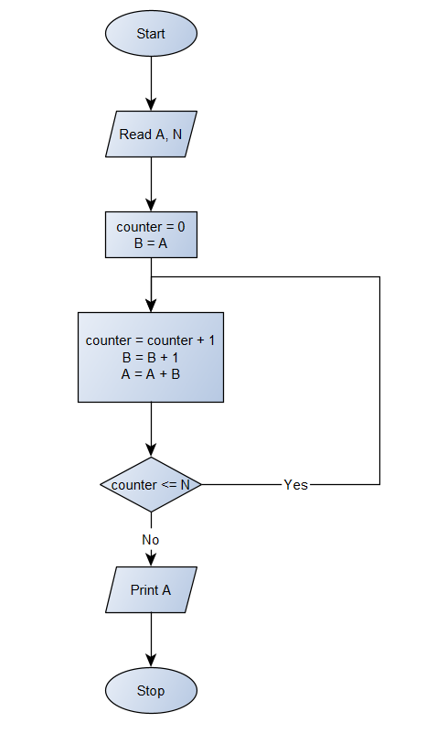

Python Program

Start_Number = int(input(**"Enter the starting number : "**))  
Number = int(input(**"Enter how many consecutive terms you want to add : "**))  
Temp_Store = Start_Number  
counter = 1  
while (counter < Number):  
 counter += 1  
 Temp_Store += 1  
 Start_Number += Temp_Store  
print(**"Sum :"**, Start_Number)